**DIABETES DETECTION SYSTEM**

**CHAPTER-1:**

**DDS DESCRIPTION AND OUTLINE**

**1.1 Diabetes**

Diabetes is a chronic (long-lasting) health condition that affects how your body turns food into energy. If you have diabetes, your body either doesn’t make enough insulin or can’t use the insulin it makes as well as it should.   
The global prevalence of diabetes among adults over 18 years of age has risen from 4.7% in 1980 to 8.5% in 2014.  
Diabetes is a major cause of blindness, kidney failure, heart attacks, stroke and lower limb amputation. In 2016, an estimated 1.6 million deaths were directly caused by diabetes. Another 2.2 million deaths were attributable to high blood glucose in 2012.  
Diabetes can be treated and its consequences avoided or delayed with diet, physical activity, medication and regular screening and treatment for complications.

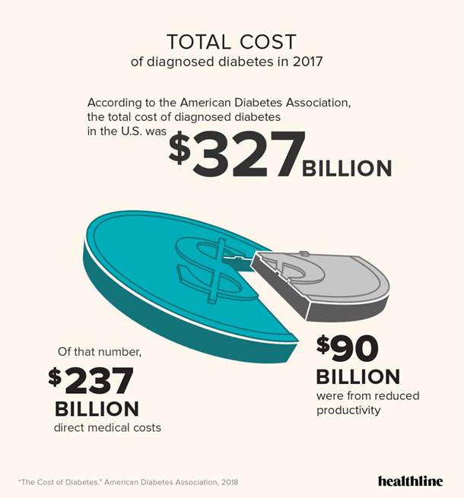

Figure 1

The three main types of diabetes are type 1 diabetes (T1D), type 2 diabetes mellitus (T2D), and gestational diabetes mellitus (GDM). Since 2000, the International Diabetes Federation (IDF) has reported the national, regional and global occurrence of diabetes. In 2009 it was estimated that 285 million people had diabetes (T1D and T2D combined) , increasing to 366 million in 2011 382 million in 2013 415 million in 2015 and 425 million in 2017 .

**1.2 Objective**

If you are facing any kind of disease or infection , knowing about the disease on time will help you to get cured and take required actions on time. This process will also help to get over with these sufferings in few days or in months. Among several diseases and sufferings, many peoples are suffering from diabetes. With this computer based diabetes detection software, user will able to do their self-checkup without taking the help of a doctor. This system will keep records of particular patients or of any person and by using their general data collected during analysis process it will able to tell you, whether you are suffering from diabetes or not. Apart from these, based on your collected data, it will also provide suggestion and general precautions which is to be taken by you in order to improve your health.

This system having the ability to detect diabetes and categorize as per the data which has been collected during questions and answer section. It’s user friendly graphical mode will enable it’s user to use this system in an interactive manner. You will have to just answer few questions . These questions have been divided into two sections. Upon completion of these questions, you will able to get your final result and your health status regarding diabetes.

To keep records, you are required to fill in your basic information and using this information, your final report will

**1.3 Summary**

It is estimated that 463 million people (95% confidence interval: 369–601 million) have diabetes in 2019. Given that half a billion people are living with diabetes, there is an urgent need for developing and implementing multi-sectoral strategies to tackle diabetes. Without urgent and sufficient actions, it is predicted that 578 million people will have diabetes in 2030 and the number will increase by 51% (700 million) in 2045.

**CHAPTER-2:**

**RELATED WORK INVESTIGATION**

**2.1 Existing work**

As per the existing system, users have to invest money before knowing their diagnosis report. They have to visit diagnostic center, consult their doctor and wait for a day to get their result. If someone have is having only a doubt and want to have a checkup, then it will lead to wastage of money and time for them. Each time you have to provide your basic information and go through the same diagnosis process to get your diagnosis result which can be dangerous in some serious condition. Patients should go through the checkup process immediately before the diagnosis process, if such conditions arise. So keeping customer records and searching their records manually sometimes is not possible and it can even be a time taking process.

**2.2 Findings from reviewed literature**

It is evident from the WHO (World Health Organization) reviewed literature that the incidence of diabetes mellitus is ever increasing throughout the world in both developed and developing countries. A significant number of people living in both developed and developing countries are ever becoming sedentary. Moreover, although there is evidence that the complications of diabetes can be prevented, there are still diabetics who lack the required knowledge and skills to manage and control their condition using available technology for healthy living and changed lifestyles.

Changing lifestyles require deliberate effort. Therefore, diabetics must take the ultimate responsibility for their care and treatment using available technology-related systems. Technologies such as meal recommendation systems, physical activity monitoring and tracking, notification systems for taking drugs, and interactive chatbots for answering questions that they may have about their condition.

The existing diabetes management applications provided relevant general information search and management while ignoring counseling services offered by medical practitioners to diabetic patients via mobile apps with data logging capability, which were crucial for managing the health condition of diabetic patients.

**CHAPTER-3:**

**SOFTWARE AND HARDWARE REQUIREMENTS**

This is a relatively light weight program and is having only some basic requirements.

**3.1 Software requirement**

* Gcc compiler
* OS - windows xp or above

( for old os , .net 4.5 framework required )

**3.2 Harddware requirement**

* Ram – 4 Gb or above
* Processor – intel core i3 or above.
* Basic display units and input units.

**CHAPTER- 4:**

**DESIGN METHODOLOGY , IT’S NOVELTY AND TECHNICAL IMPLIMEMNGTATION**

**4.1 Proposed system**

All your previous and new records will be saved using the concept of file and directory. Binary search operation will be performed while searching your record and you will also able to get your previous diagnosis report while using this system. This system will able to identify your sufferings related to diabetes and store it into the file with your record id. Each patient will have particular record id and while searching, patients can differentiate between their details and others by selecting their date of birth and address details.

**4.2 Flowchart of basic working**

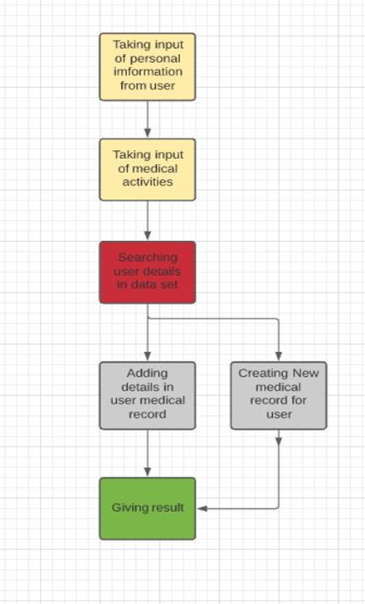

Figure 2

**4.3 Basic module split-up**

1. Welcome display module
2. Value input module
3. Level 1 symptoms
4. Level 2 symptoms
5. Level 3 symptoms
6. Analyzing Modules
7. Result display module

**4.4 Architecture Diagram**

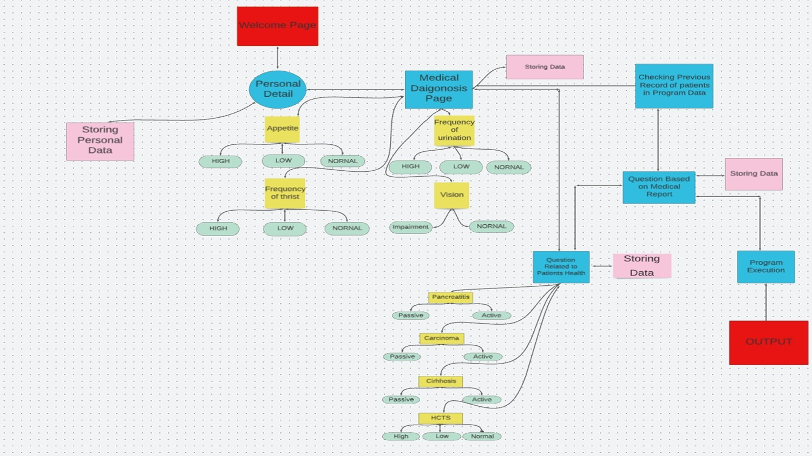

Figure 3

**CHAPTER-5:**

**CONCLUSION**

The proposed framework factors the diabetes management problem into subgoals, it allows users to get proper recommendations. The reviewed literature presented some gaps which informed the design and development of an integrated diabetes management platform for patients providing an interactive visual interface to help them make meaning of their readings and establishing a sufficient connection between the doctor and the diabetic patient. The implemented system would solve the problem of managing medication for diabetics. Finally, there is hope that this system will be useful to people with diabetes now and in the future. The focus of this work has been on implementing a software system that will take into consideration the various factors that affect diabetics.